Homework 1 – Lanz Compala

1. Install the QA database. Include a screenshot showing SQL Server with the database expanded to show table names. (Submit all screenshots in a single word file).  
     
   Answer:  
   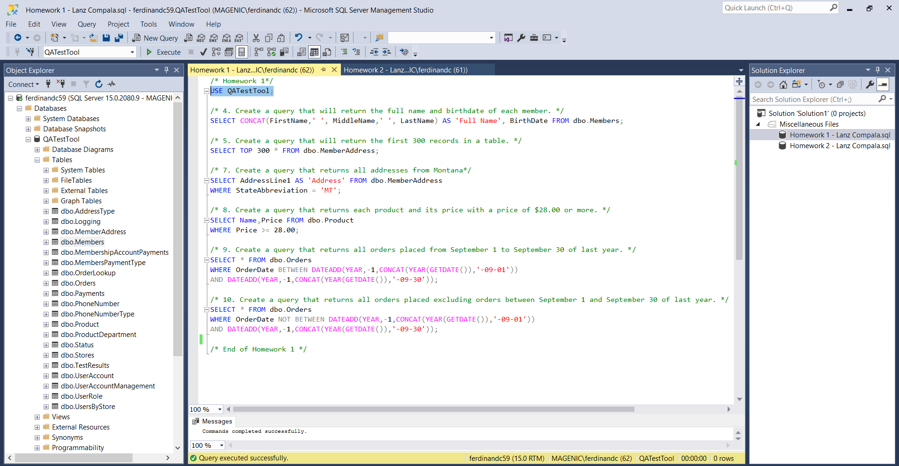
2. Describe the relationship of Primary and Foreign keys. Can a table have more than one primary or foreign key?  
     
   Answer:  
   Primary key is the unique identifier of a database table while foreign key references the primary key of another table to establish a connection between the two tables. The relationship of primary and foreign key is to join two or more tables to gather desired information.   
   A table can only have one primary key while it can have multiple foreign keys.
3. List all user created stored procedures.  
     
   Answer:  
   - USP_AddMemberMach2  
   - USP_AddMemberMach3  
   - USP_AddUser  
   - USP_NewOrder

6. List all dependencies of the Stores table. (A screenshot is acceptable)

Answer:  
